Natalia Palej

A00279259@student.tus.ie   
Year 3 Semester 1

Sprint #2

Web Development 3.1

Student ID: A00279259

Table of Contents

User Stories 2

Database/Makeup User Stories 2

User User Stories 2

Testing 3

Database/Makeup Test Cases 3

Test #1 3

Test #2 4

Test #3 5

Test #4 6

Test #5 7

User Test Cases 8

Test #1 8

Test #2 9

Test #3 10

Test #4 11

Test #5 12

Test #6 13

Test #7 14

Test #8 15

Test #9 16

Test #10 18

Test Report 19

Bugs Report 19

Bug #1 19

References 20

Screencast Link 20

# User Stories

## Database/Makeup User Stories

1. As a Makeup CEO, I want to connect server and database, so that I can access my inventory through local server.
2. As a Makeup CEO, I want to add product so I can have extra products in my store.
3. As a Makeup CEO, I want to update product info, so I can keep accurate information.
4. As a Makeup CEO, I want to delete product that I no longer stock.

## User User Stories

1. As a User, I want to log in, so that I can have access to the account.
2. As a User, I want to log out, so that my account stays secure.
3. As a User, I want to register, so I can create a new account.
4. As a User, I want to search through products, so I can decide which one to purchase.
5. As a User, I want to search for product by name/category/company, so that I can filter the result.
6. As a User, I want to be able to edit my details, so that I keep information up to date.
7. As a User, I want to be able to delete my account, so that I can no longer use the app.

# Testing

## Database/Makeup Test Cases

**PRE-REQUISITES:**

Before conducting each test, it is assumed the below conditions are met:

1. Database is up and running (xampp + workbench)
2. Web browser is opened.
3. URL entered is http://localhost/Assessment/Sprint2 /<html-file>

### Test #1

|  |  |
| --- | --- |
| User Story | Get server connection |
| Test Case ID | #1 |
| Description | Verify valid URL |
| Given | 1. Database is running (xampp + workbench) 2. Valid API route was entered |
| When | 1. Double-click on .html file 2. Ensure route is <http://localhost/Assessment/Sprint2/login.html> 3. Press enter |
| Then | HTML page loads up |
| Test Result | Passed Failed |

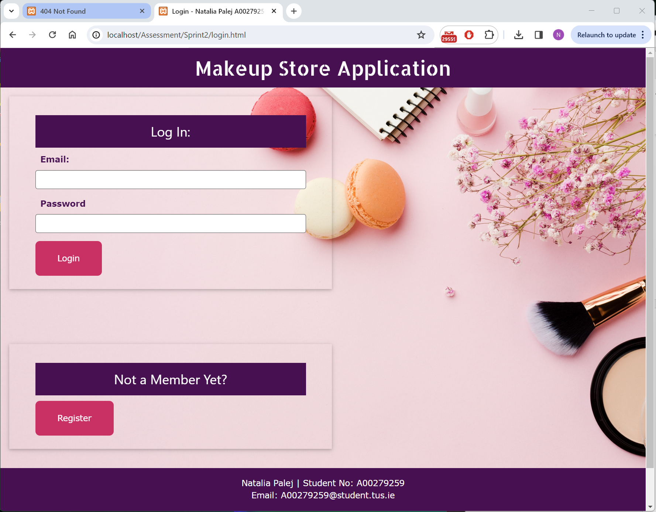

### Test #2

|  |  |
| --- | --- |
| User Story | Get server connection |
| Test Case ID | #2 |
| Description | Verify invalid URL |
| When | Enter invalid URL: <http://localhost/login.html> |
| Then | Error 404 “Not Found” |
| Test Result | Passed Failed |

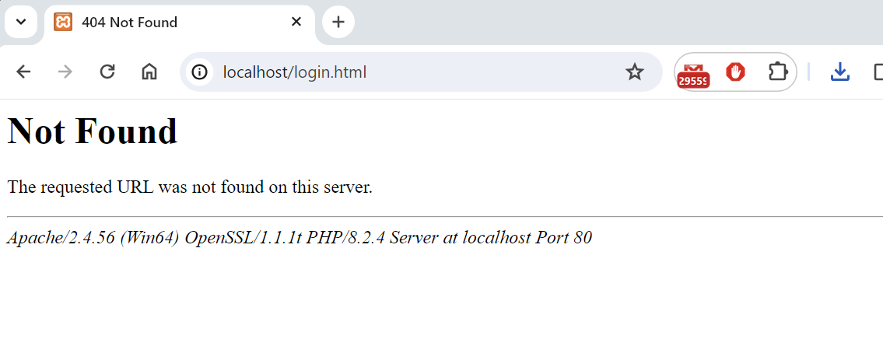

### Test #3

|  |  |
| --- | --- |
| User Story | Add products to the database |
| Test Case ID | #3 |
| Description | Verify new product can be added |
| When | <http://localhost/Assessment/Sprint2/admin.html> Add Tab  Product Name: CHARLOTTE TILBURY BEAUTY LIGHT WAND  Category: face  Description: This dreamy highlighter flatters all skin tones and is brimming with treated pearls to give a luminous, soft-focus finish. Free from giveaway glitter or sparkle, this believable radiance potion is perfectly applied using the soft cushion applicator pad, which delivers and blends product evenly.  Company: Charlotte Tilbury  Price: 33.90 Stock: 180 Sale: No  Discontinued: No Picture: charlotte-contour-wand.png |
| Then | Alert “success : addProduct() Product <name> added successfully” |
| Test Result | Passed Failed |

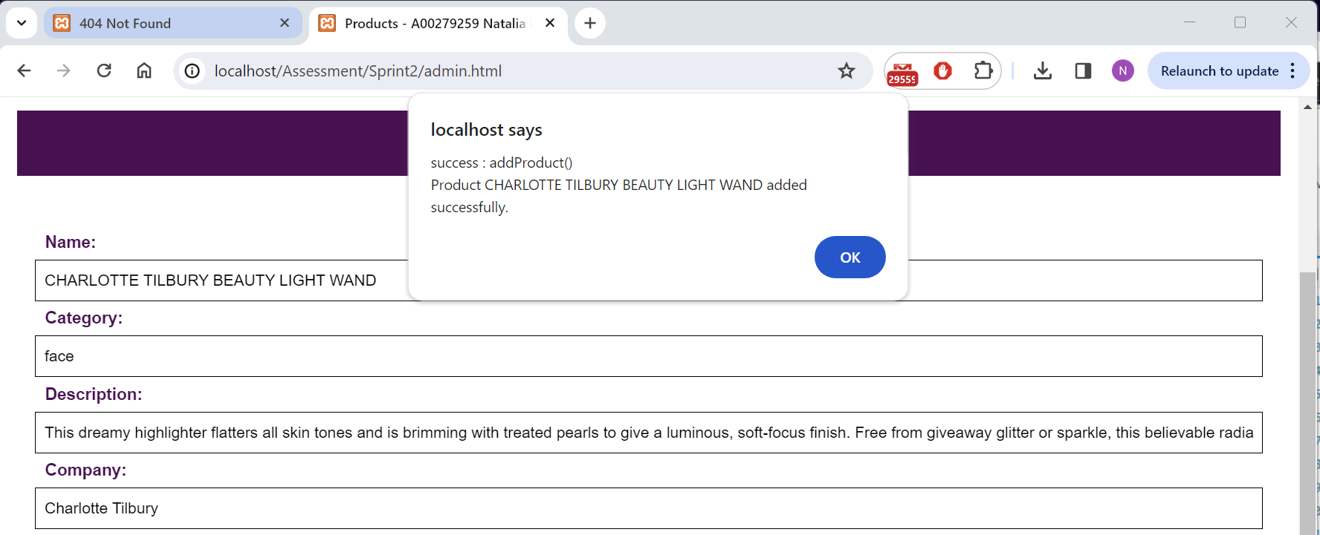

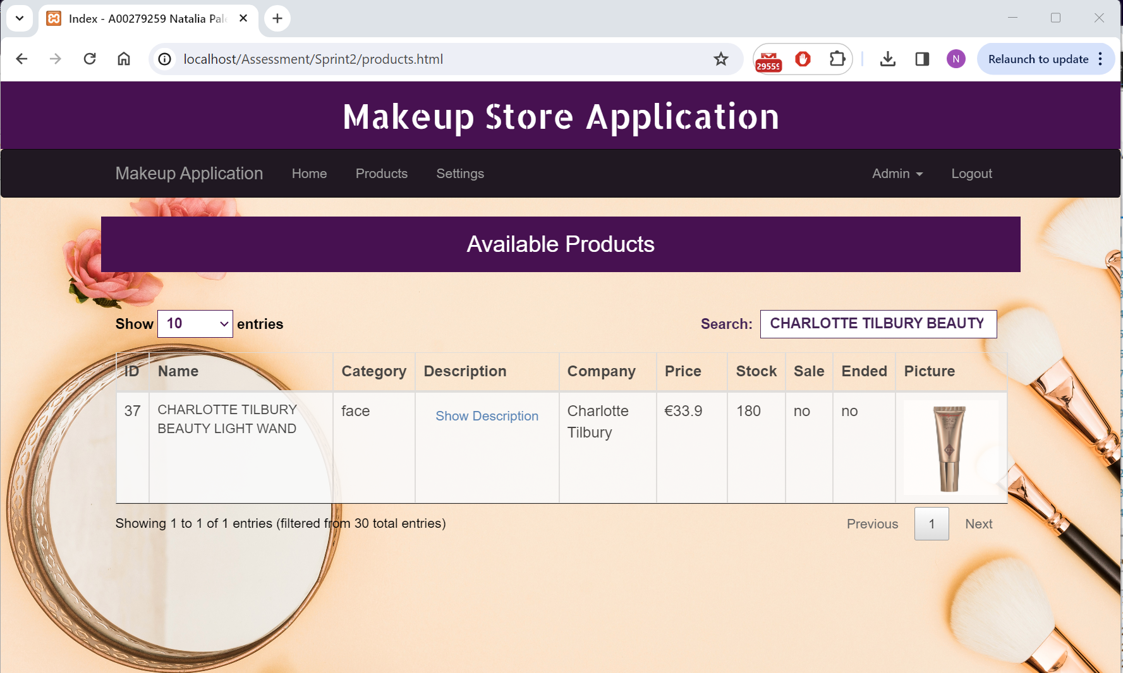

### Test #4

|  |  |
| --- | --- |
| User Story | Update product details in database based on its ID |
| Test Case ID | #4 |
| Description | Verify product was successfully updated |
| When | <http://localhost/Assessment/Sprint2/admin.html> Update Tab  ProductID = 37  Update to price = 24.50, sale = yes |
| Then | Alert “success : Product updated <productID> <productName> |
| Test Result | Passed Failed |

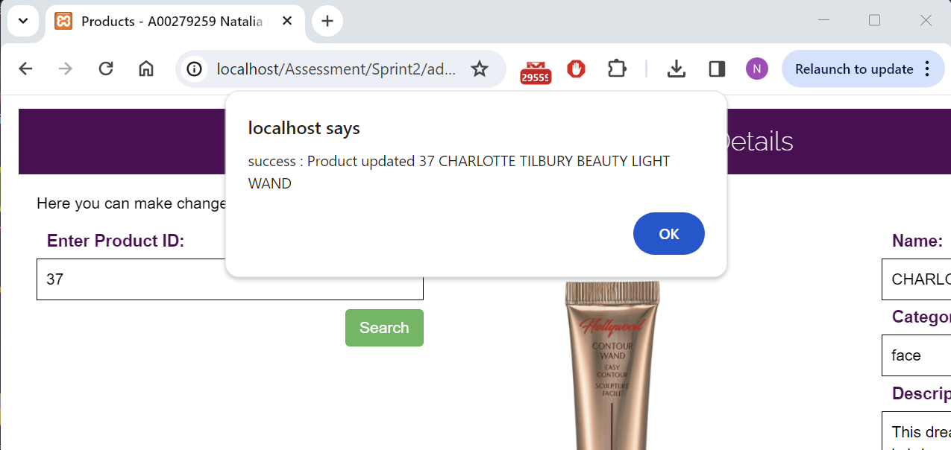

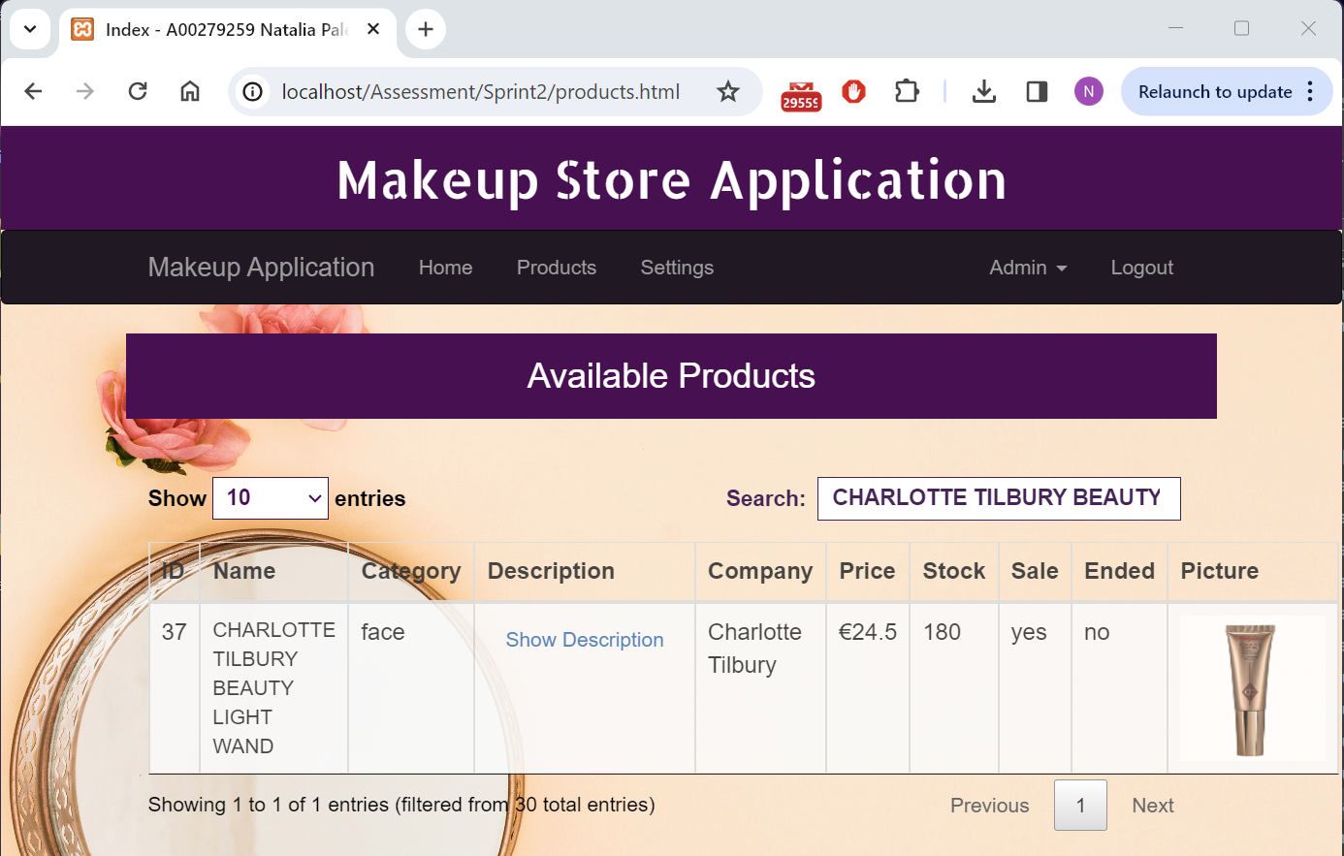

### Test #5

|  |  |
| --- | --- |
| User Story | Delete product from the database based on its ID |
| Test Case ID | #5 |
| Description | Verify product was successfully deleted |
| When | <http://localhost/Assessment/Sprint2/admin.html> Delete Tab  ProductID = 37 |
| Then | Alert “success : product <productID> deleted. You will be directed to Admin page” |
| Test Result | Passed Failed |

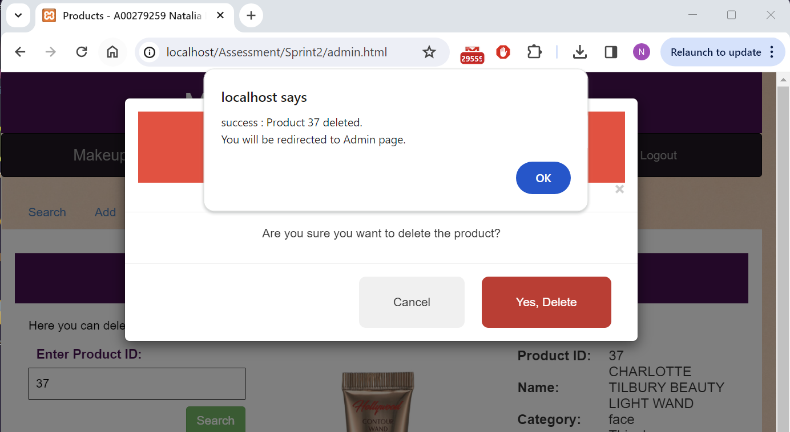

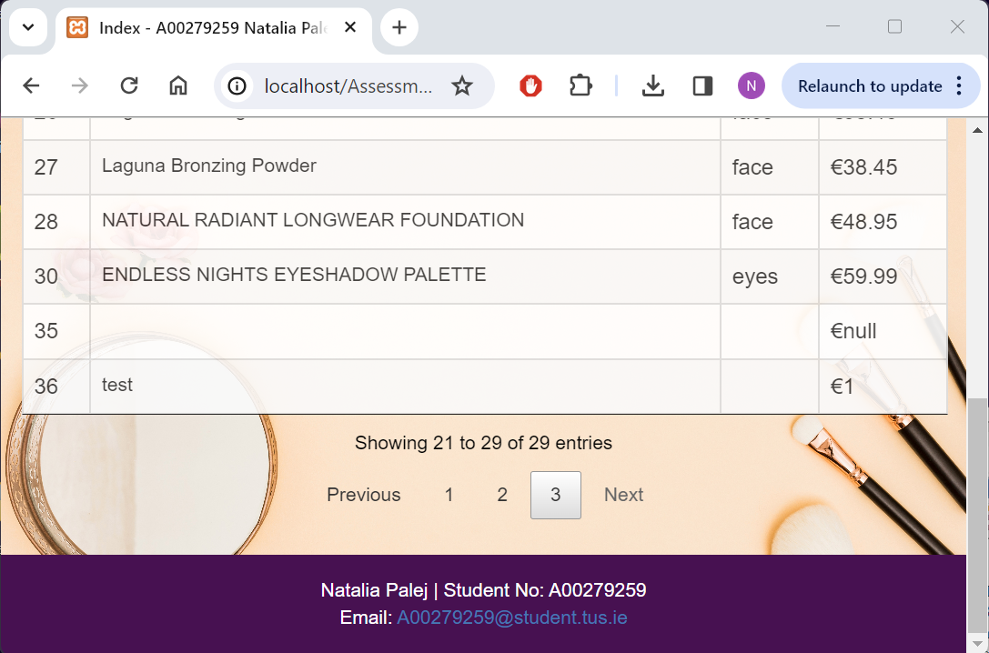

## User Test Cases

### Test #1

|  |  |
| --- | --- |
| User Story | Log in to the application |
| Test Case ID | #1 |
| Description | Verify user can log in with valid credentials |
| When | Valid credentials entered:  Email: Test Password: Test |
| Then | User is redirected to index.html page |
| Test Result | Passed Failed |

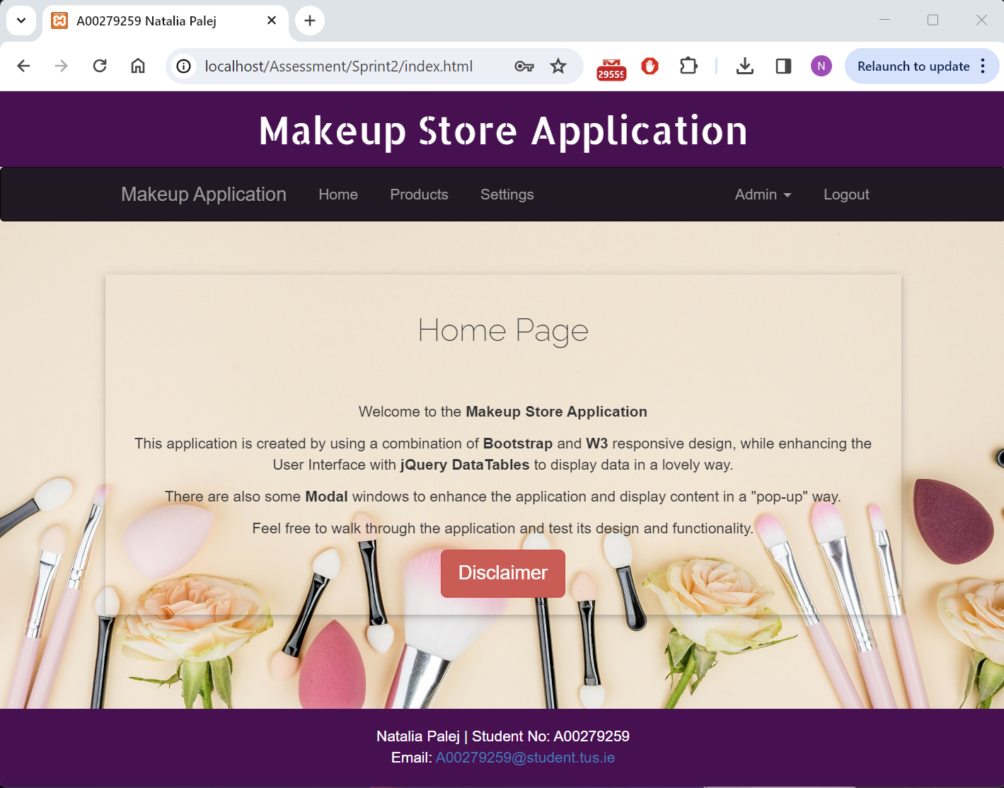

### Test #2

|  |  |
| --- | --- |
| User Story | Log in to the application |
| Test Case ID | #2 |
| Description | Verify error thrown when invalid credentials are entered |
| When | Invalid credentials entered  Email: Teest Password: Test |
| Then | Alert “error : Invalid email or password. Please try again.” |
| Test Result | Passed Failed |

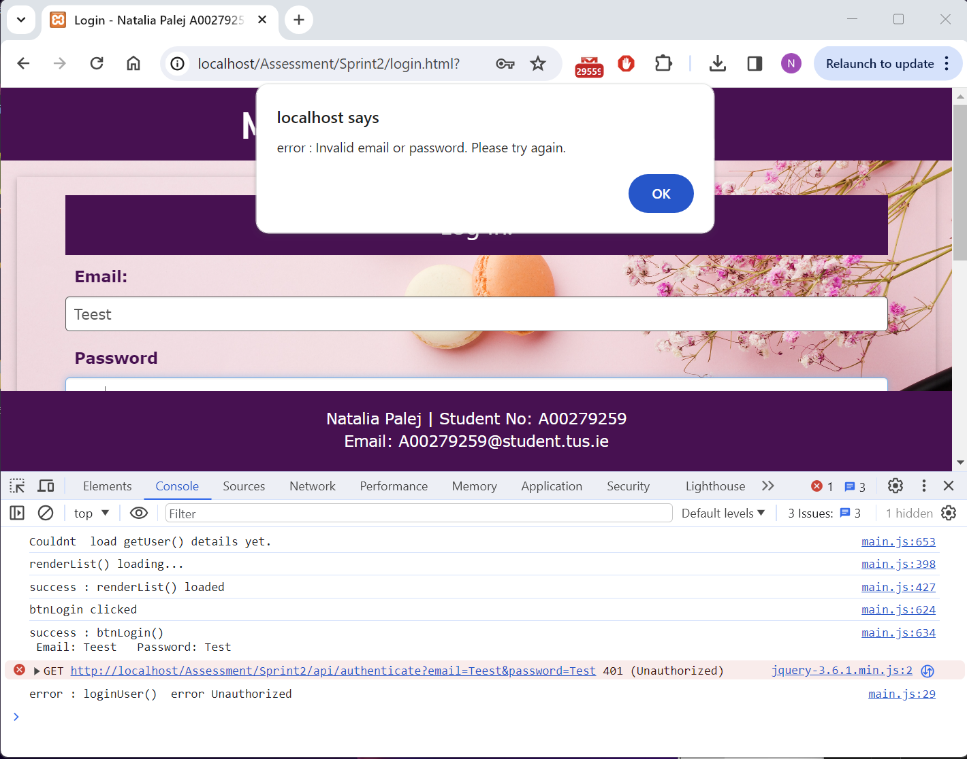

### Test #3

|  |  |
| --- | --- |
| User Story | Log out from the application |
| Test Case ID | #3 |
| Description | Verify user can successfully log out and session is closed |
| When | Logout button and confirmation buttons is clicked. |
| Then | User is redirected to logout.html |
| Test Result | Passed Failed |

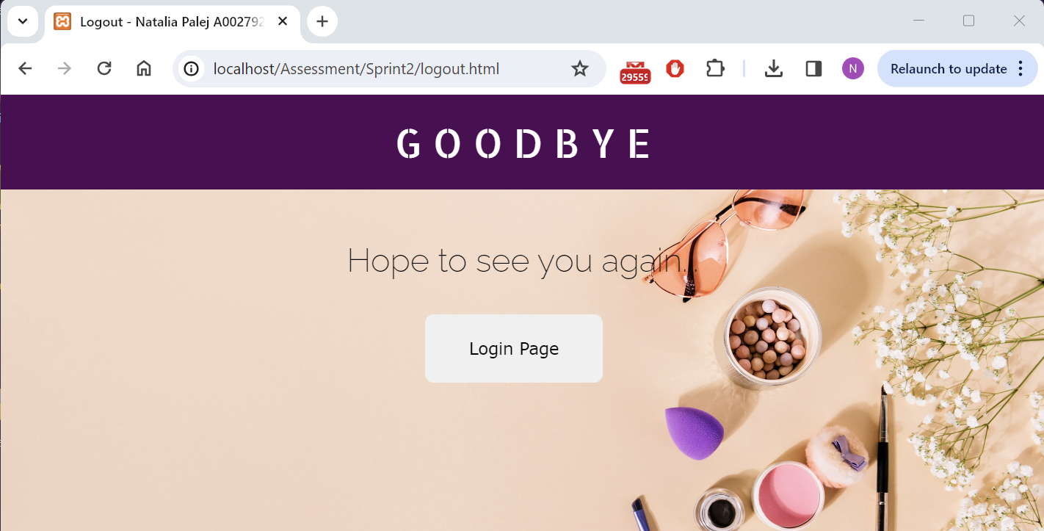

### Test #4

|  |  |
| --- | --- |
| User Story | Register to the application |
| Test Case ID | #4 |
| Description | Verify new user is added to database |
| When | <http://localhost/Assessment/Sprint2/register.html>  Name: Test  Last Name: Test  Username: Test  Email: Test  Password: Test  Address: Test  Phone No: Test  Picture: avatar.png |
| Then | Alert “success : addUser() User <firstName> <lastName> added successfully. |
| Test Result | Passed Failed |

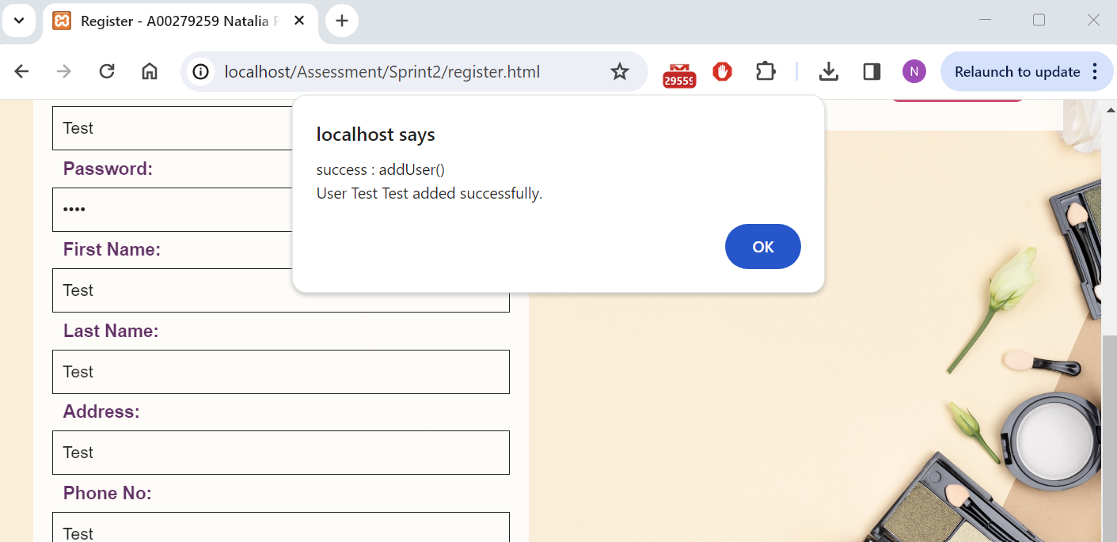

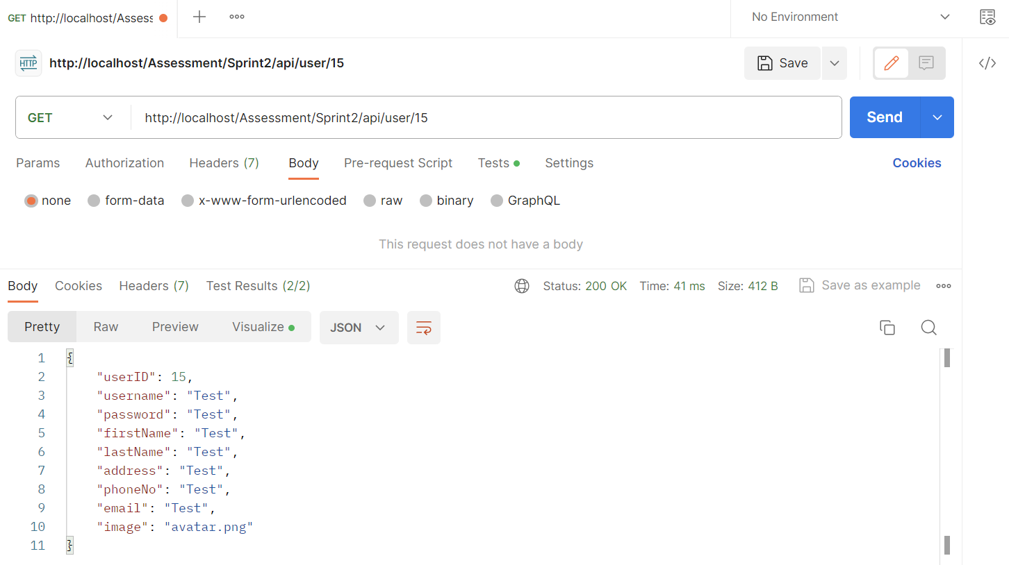

### Test #5

|  |  |
| --- | --- |
| User Story | Search through products dynamically |
| Test Case ID | #5 |
| Description | Verify user can search through products using bootstrap dataTable |
| When | http://localhost/Assessment/Sprint2/products.html  Search: agi |
| Then | Products that contain “agi” in any field will appear |
| Test Result | Passed Failed |

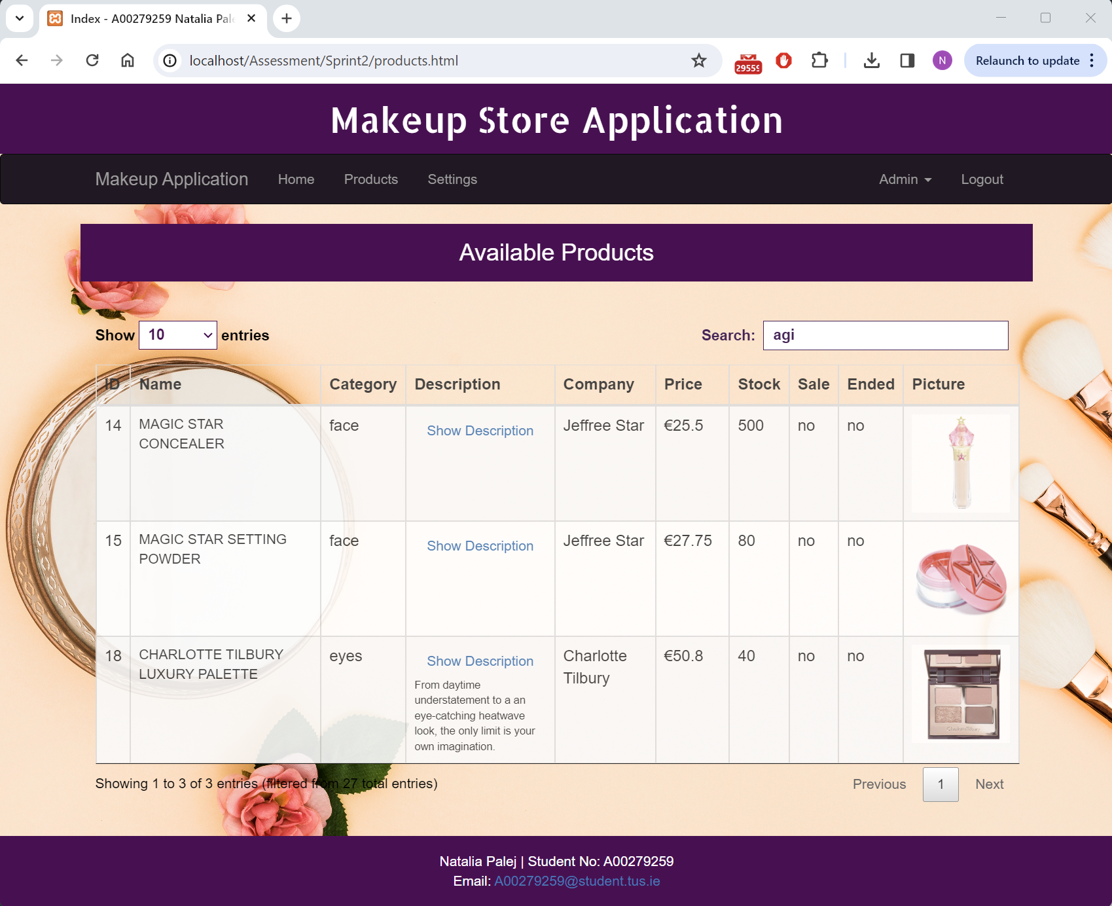

### Test #6

|  |  |
| --- | --- |
| User Story | Search for product by its name |
| Test Case ID | #6 |
| Description | Verify user can search for product by its name |
| When | <http://localhost/Assessment/Sprint2/admin.html> Search Tab  Enter Product Name: Magic |
| Then | Product will appear beside the search field |
| Test Result | Passed Failed |

Before:

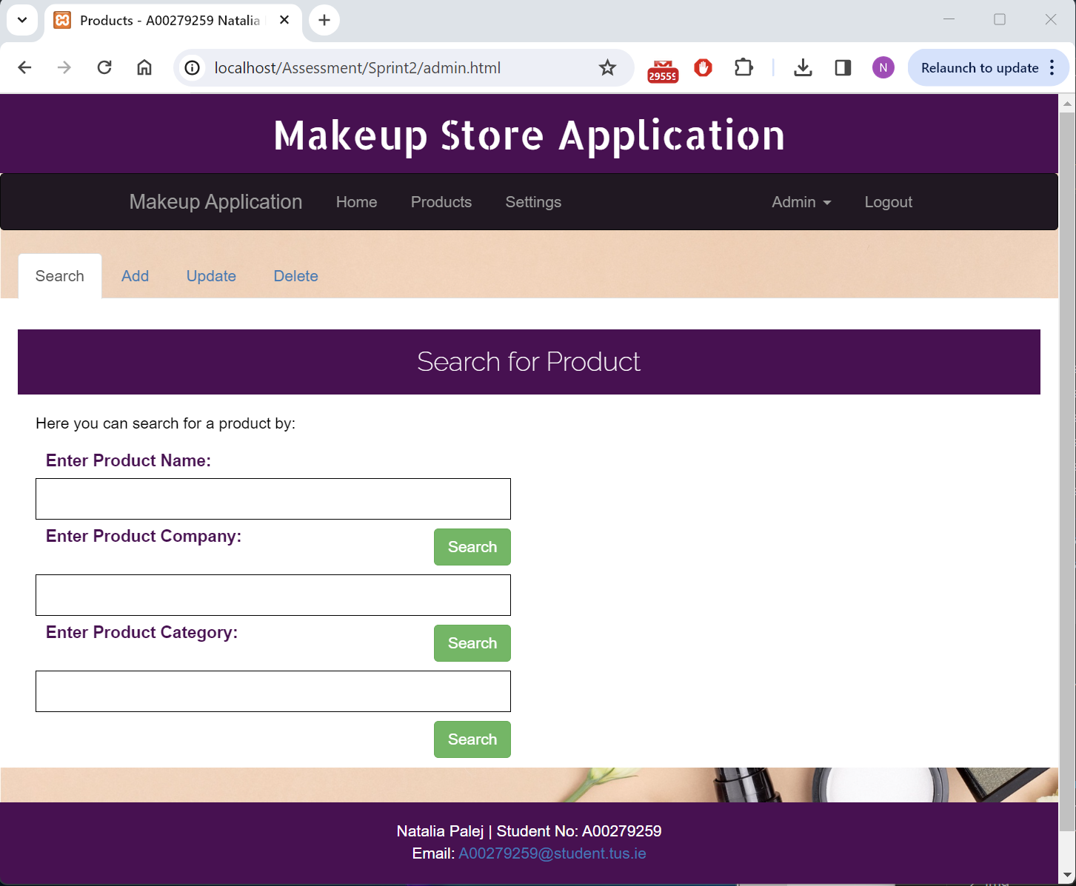

After:

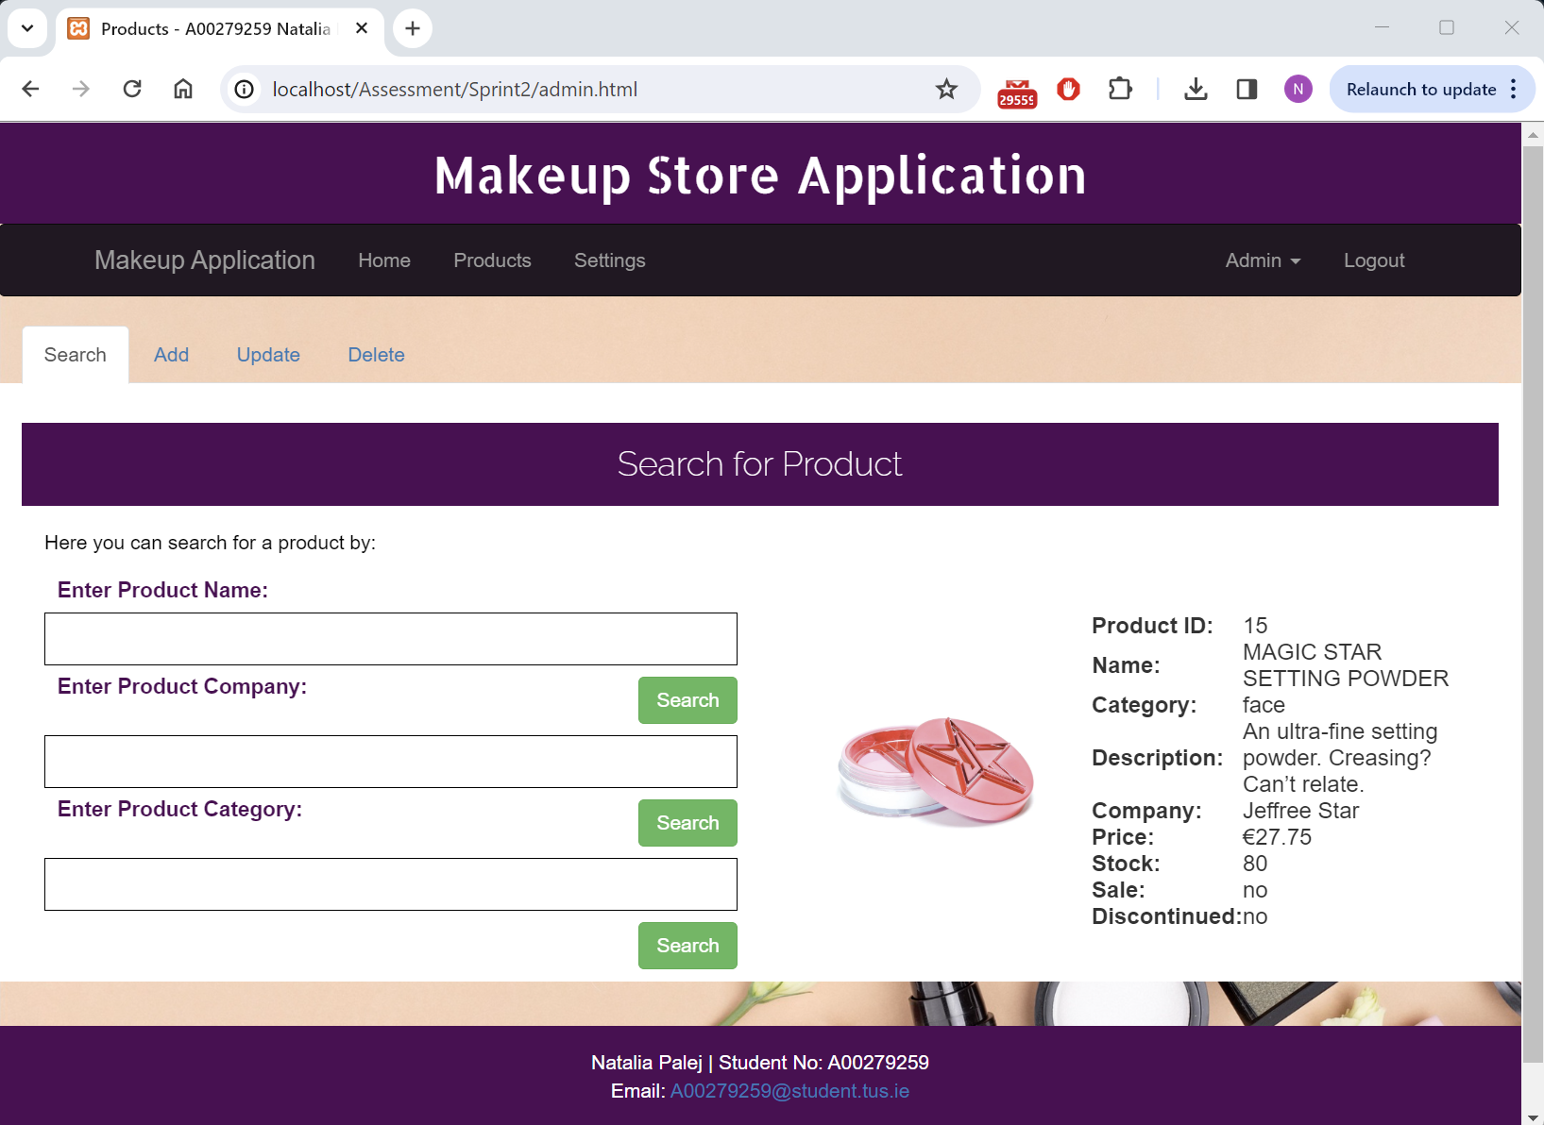

### Test #7

|  |  |
| --- | --- |
| User Story | Search for product by its company name |
| Test Case ID | #7 |
| Description | Verify user can search for products by company name |
| When | <http://localhost/Assessment/Sprint2/admin.html> Search Tab  Enter Product Company: Benefit |
| Then | All Benefit products will appear below the search tabs |
| Test Result | Passed Failed |

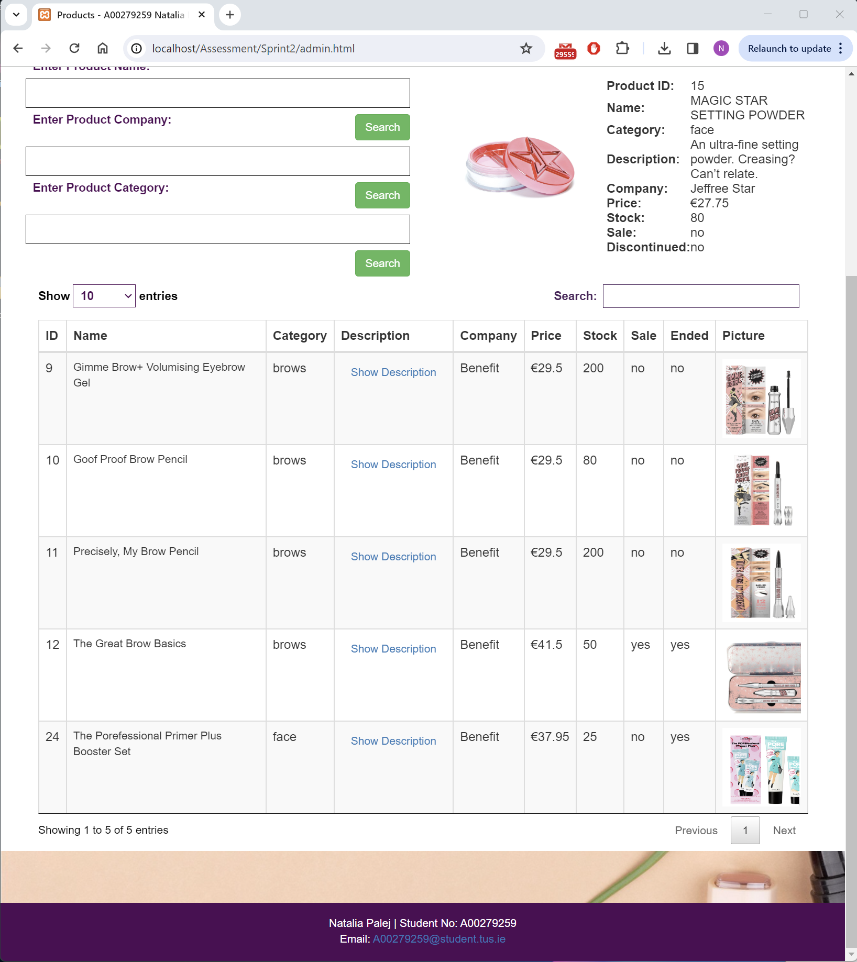

### Test #8

|  |  |
| --- | --- |
| User Story | Search for product by its category |
| Test Case ID | #8 |
| Description | Verify user can search for products based on the category |
| When | <http://localhost/Assessment/Sprint2/admin.html> Search Tab  Enter Product Category: lips |
| Then | All lips products will appear below the search fields |
| Test Result | Passed Failed |

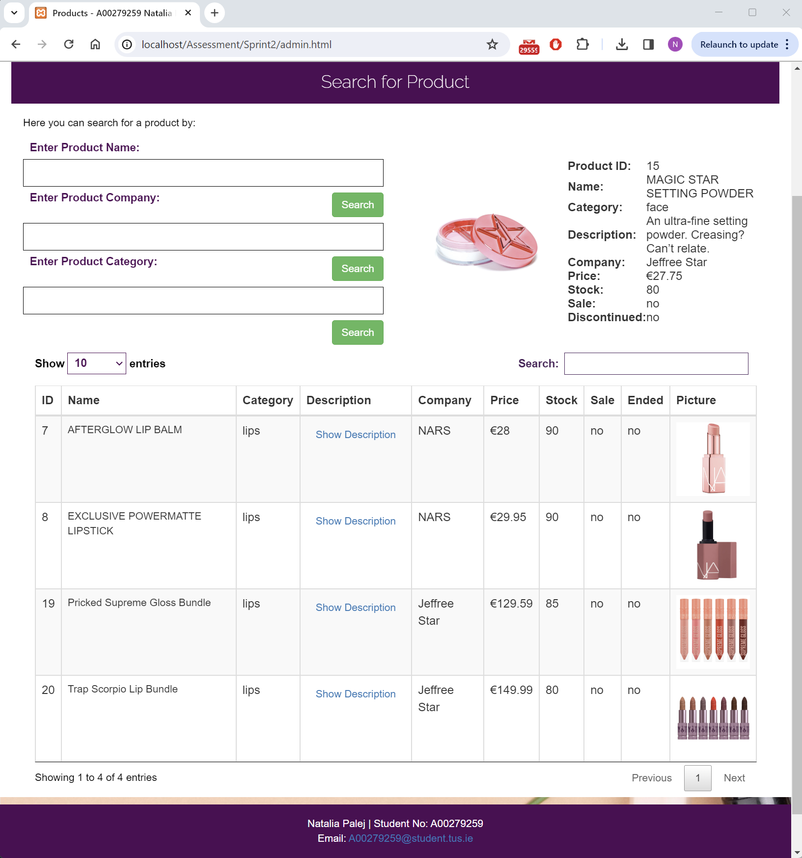

### Test #9

|  |  |
| --- | --- |
| User Story | Update user details |
| Test Case ID | #9 |
| Description | Verify user can update their details |
| When | <http://localhost/Assessment/Sprint2/settings.html> Update Tab  Update First Name: Natalia Email: [natalia@gmail.com](mailto:natalia@gmail.com) Username: Nat  Picture: avatar.jpg |
| Then | Alert “success: updatUser() User <userID> <firstName> updated successfully” |
| Test Result | Passed Failed |

Before:

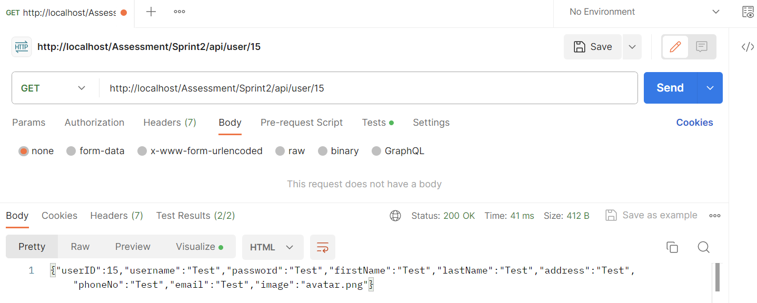

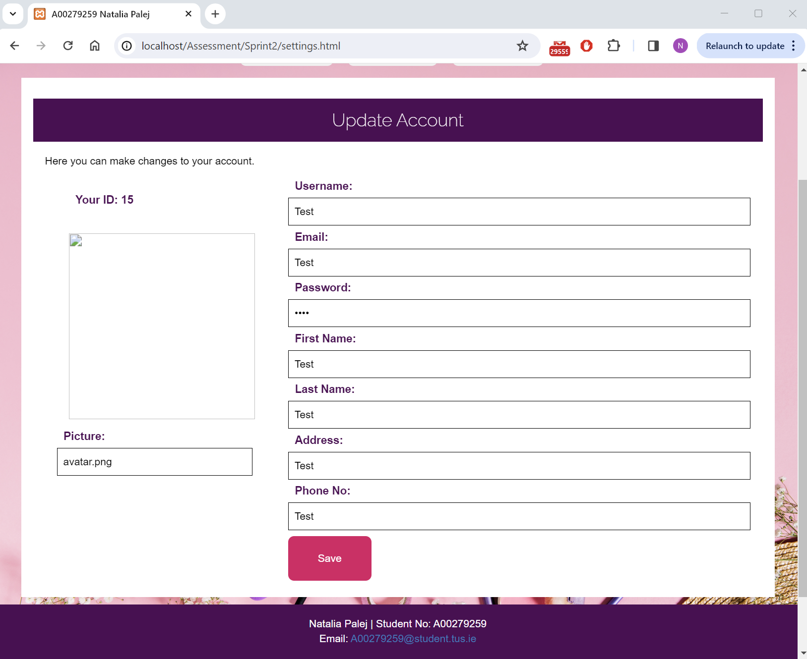

After:

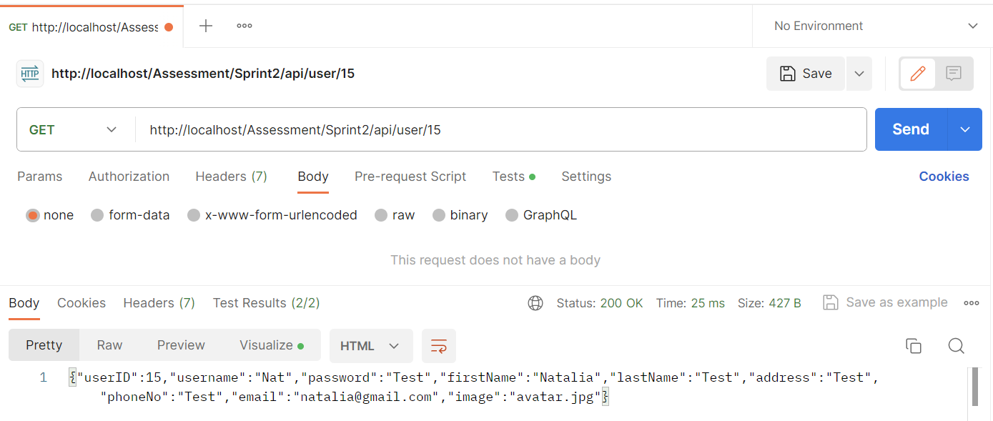

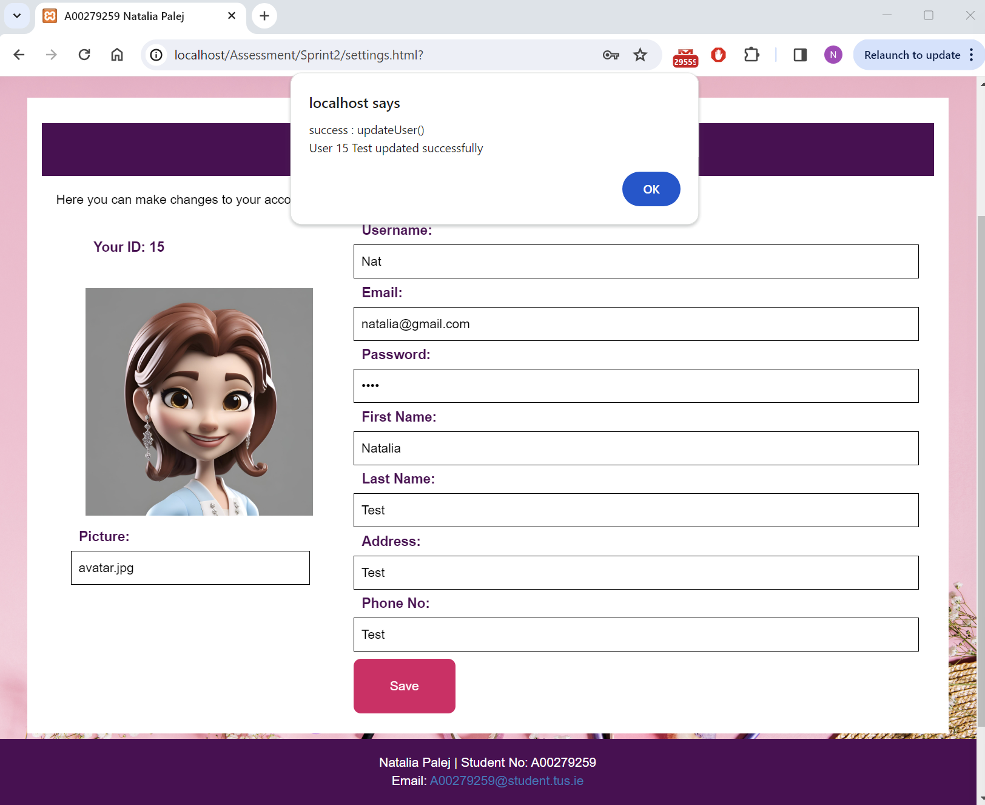

### Test #10

|  |  |
| --- | --- |
| User Story | Delete user account |
| Test Case ID | #10 |
| Description | Verify user can delete their account |
| When | <http://localhost/Assessment/Sprint2/settings.html>? Delete Tab  Delete button and confirmation clicked. |
| Then | Alert “success : deleteUser() User <userID> <firstName*> was deleted. You will be redirected to login page now. |
| Test Result | Passed Failed |

*since I do not set new session details for logged in user after updating, “Test” appears as initially that was my “name” field.

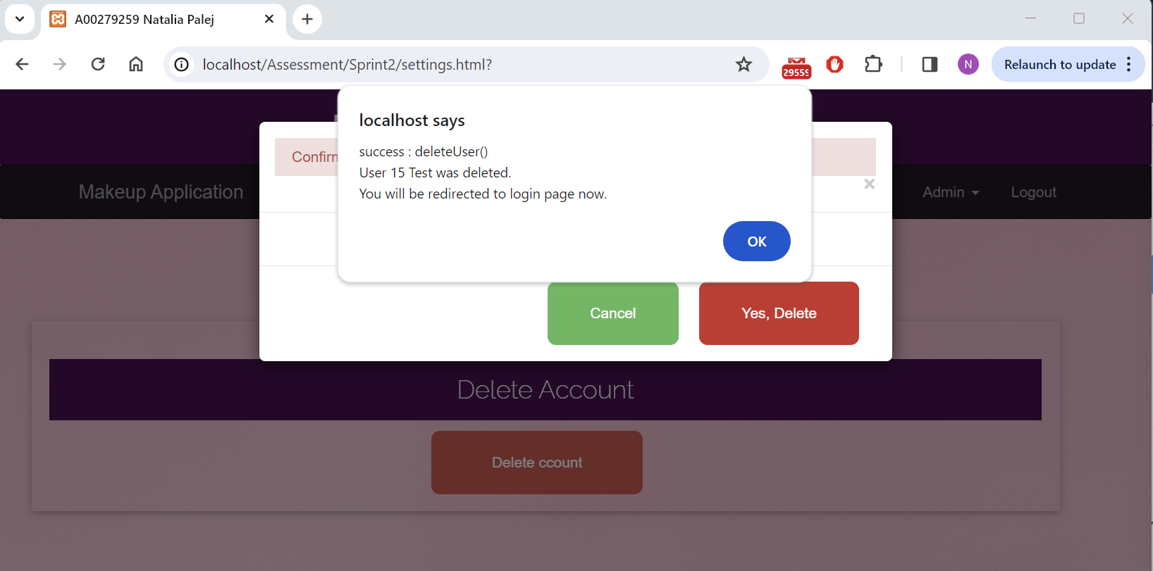

Postman Verification:

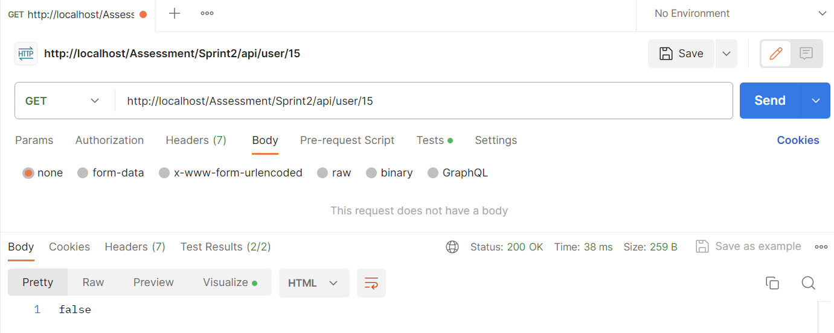

Login Verification: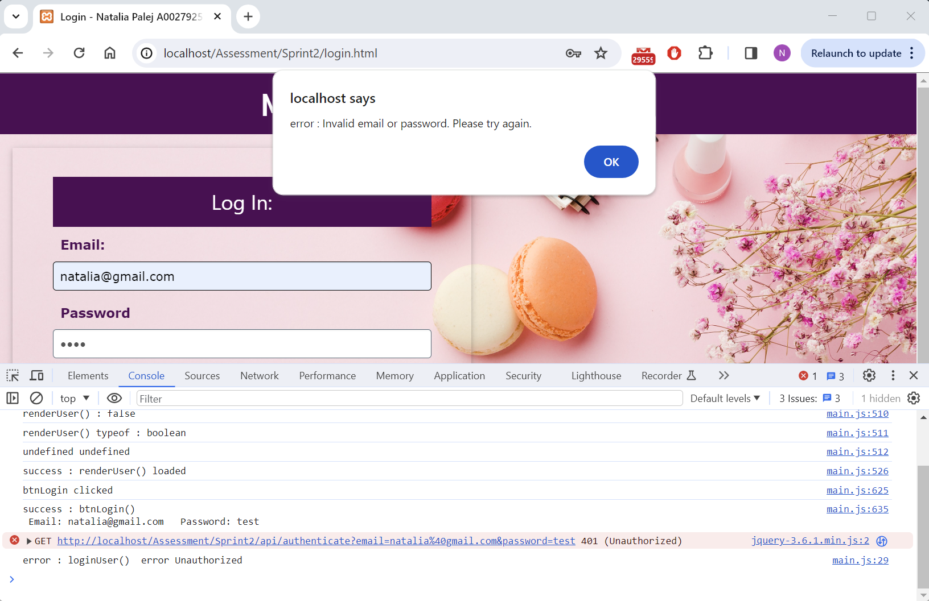

## Test Report

|  |  |  |  |  |
| --- | --- | --- | --- | --- |
| **Test Type** | **Database** | **Total Tests** | **Number Passed** | **Number Failed** |
| Manual | CEO | 5 | 5 | N/A |
| User | 10 | 10 | N/A |

## Bugs Report

### Bug #1

|  |
| --- |
| Bug Description |
| N/A |
| Resolution |
| N/A |

# References

1. Used w3schools for:
   1. W3 CSS <https://www.w3schools.com/w3css/default.asp>
   2. CSS <https://www.w3schools.com/css/default.asp>
   3. Back Button Method
      1. <https://www.w3schools.com/jsref/obj_location.asp>
      2. <https://www.w3schools.com/jsref/met_his_back.asp>
   4. Bootstrap <https://www.w3schools.com/bootstrap/bootstrap_ver.asp>
2. Fonts Taken From: <https://fonts.google.com/specimen/Edu+TAS+Beginner>
3. Background Images and Avatars downloaded from:
   1. <https://www.freepik.com/>
4. Product Images and Details taken from:
   1. <https://www.cultbeauty.com/>
   2. <https://www.beautybay.com/>

# Screencast Link